

2B Chemistry
Redox & Organic Topic Test

Instructions to students:

Answer all questions (including multiple-choice questions) in the answer booklet

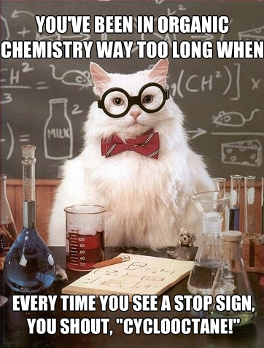
Multiple-choice Section

- Which of the following has the greatest increase in oxidation number from the elemental state of the element?
  - Cu⁺
  - Mg²⁺
  - Pb⁴⁺
  - O²⁻

- Which of the following does not represent a Redox equation?
  - 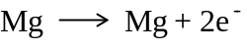
  - 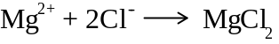
  - 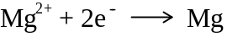
  - 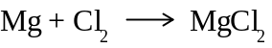

- Which of the following chemical equations shows oxygen being oxidized?
  - 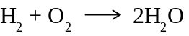
  - 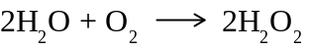
  - 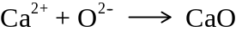
  - 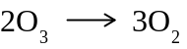

- In which one of the following molecules is nitrogen in the highest oxidation state?
  - N₂
  - N₂O₅
  - NO
  - N₂O₄

- Zn, CO and H₂ are all reducing agents. Which one of the following statements best explains why this is the case?
  - They can all readily donate electrons.
  - They are all difficult to oxidize.
  - None of them can be reduced.
  - They all react with oxygen.

- Which one of the following represents oxidation?
  - 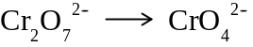
  - 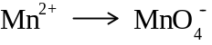
  - 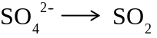
  - 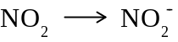

- Methanol, which can be used in fuel cells to provide power for notebook computers, can be produced by the following redox reaction:

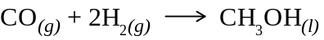

Which of the following statements is true?
  - In this reaction hydrogen is the oxidizing agent and carbon monoxide is the reducing agent.
  - The oxidation number of carbon changes from +2 to -2.
  - The oxygen has been reduced.
  - The hydrogen has been reduced.

- Which one of the four elements (S, C, Cl, Cr) shown in Highlighted below has the lowest oxidation number?
  - KHSO₄ 6
  - Na₂C₂O₄ 3
  - HOCl 1
  - K₂Cr₂O₇ 6

- Examine the molecule below:
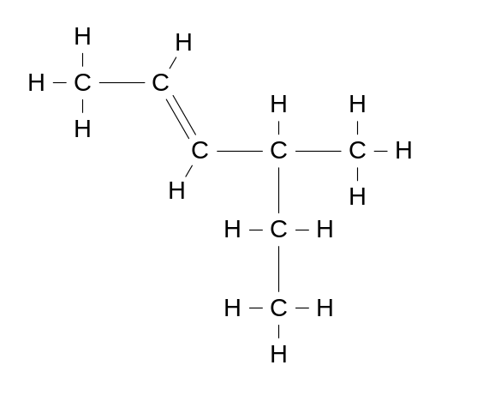
Which of the following is the correct name for this molecule?
  - 4-methylhex-2-ene
  - Trans 4-methylhex-2-ene
  - Cis 4-methylhex-2-ene
  - Trans 4-ethylpent-2-ene

- Which of the following hydrocarbons does not have the molecular formula 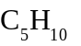?
  - 1-Methylcyclobutene
  - Pentene
  - Methylbutene
  - Cyclopentane

- How many hydrogen atoms are there in one molecule of 2,3-dimethylecycloheptene?
  - 12
  - 14
  - 16
  - 18

- How many atoms are there in any molecule of diethylhexene?
  - 33
  - 22
  - 14
  - 7

- Which one of the following compounds can show cis-trans isomerism?
  - CH₃CH₂CH₂Cl
  - Cl₂C=CClCH₃
  - CH₂ClCHClCH₃
  - ClCH=CClCH₃

- Which one of the following compounds is an isomer of butane?
 | 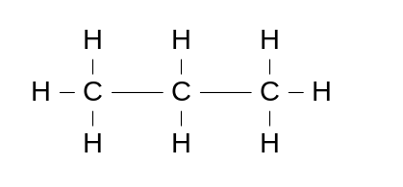 |  | 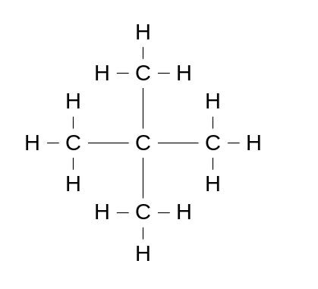
 | 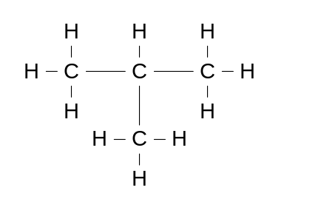 |  | 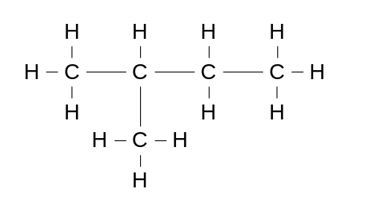

- A commonly-used test in organic chemistry is to shake a sample of a compound with bromine water and observe the colour change, if any, of the bromine water.
Which one of the following compounds would not cause the colour of the bromine water to fade in such a test?
  - Ethene
  - KCl
  - MgF₂
  - Methycyclobutene

End of multiple-choice section

Stage 2 Chemistry
Redox & Organic Chemistry Test
Answer Booklet

Name:

Score: /55
Multiple-Choice section: Answer by shading the square to the left

 | - a | - b | - c | - d
 | - a | - b | - c | - d
 | - a | - b | - c | - d
 | - a | - b | - c | - d
 | - a | - b | - c | - d
 | - a | - b | - c | - d
 | - a | - b | - c | - d
 | - a | - b | - c | - d
 | - a | - b | - c | - d
 | - a | - b | - c | - d
 | - a | - b | - c | - d
 | - a | - b | - c | - d
 | - a | - b | - c | - d
 | - a | - b | - c | - d
 | - a | - b | - c | - d

- The following chemical reaction is given a special name.

  - What is that name? Disproportionation [1]

  - Explain (using an example) why this reaction is given that name: [2]
In this type of reaction one element is both oxidised and reduced.
In this case elemental phosphorus has an oxidation number of 0, but in PH₃ is it -3, and in H₂PO₂⁻ it is +1,

- State the oxidation number of the underlined element in each of the following: [6]

  - NaOH +1
  - MgH₂ -1
  - HAsO₄ +7
  - HClO₄ +7
  - Cr₂O₇⁻² +6
  - O₃ 0

In industry, sodium is extracted from molten sodium chloride by electrolysis. Likewise, potassium can be extracted from its molten salts.
  - Write the oxidation and reduction half equations for the electrolysis of molten potassium fluoride. [2]

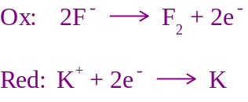

In the extraction of potassium from molten potassium fluoride, an apparatus similar ro that shown in the diagram below is used. Refer to the diagram to answer the parts of the question that follow.

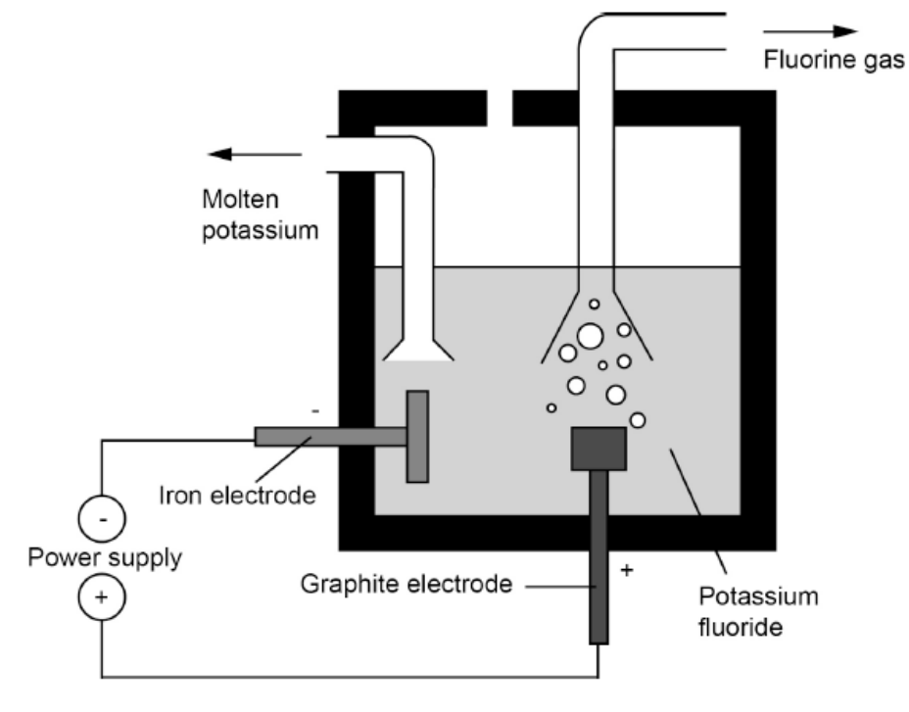

  - Complete the table below by writing the electrode (anode or cathode) for which each of the substances shown is used. [1]

Graphite | Iron
Anode | Cathode

  - On the diagram, show clearly the direction of flow of fluoride ions. [1]

Toward the graphite electrode (anode)

  - Name the substance that forms at the anode. [1]

Fluorine gas

  - Explain why solid potassium fluoride cannot undergo electrolysis [2]

In electrolysis the ions need to be mobile (1),
In solid ionic substances the ions are not mobile (1)
- A group of students conducted a series of experiments to determine the relative reductive strength of metals. They placed strips of each metal in soluble solutions of the other metals ions.
Their results are recorded in the table below

 | Sn²⁺_{(aq)} | Ni²⁺_{(aq)} | Cu²⁺_{(aq)} | Cr³⁺_{(aq)}
Cu_{(s)} | N.V.R. | N.V.R. |  | N.V.R.
Cr_{(s)} | V.R. | V.R. | V.R
Sn_{(s)} |  | N.V.R. | V.R. | N.V.R.
Ni_{(s)} | V.R |  | V.R | N.V.R.
N.V.R. = No Visible Reaction. V.R. = Visible reaction

- List the metals in order from strongest reductant to weakest reductant. [2]

Chromium, Nickel, Tin, Copper
^{Strongest} ^{Weakest}
- Which of the substances in this experiment was the strongest oxidant? [1]

Copper II ion (Cu²⁺)

- For the reaction that occurred between copper and chromium:

    - Oxidation half equation: [1]

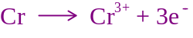

    - Reduction half equation: [1]

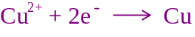

    - Full equation Redox [1]

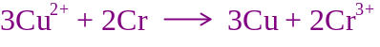

- What observations would the students have made for the reaction between copper and chromium? [2]

A pale blue solution would become dark green

Salmon pink crystals form on the chromium metal

- Propane is commonly used as a fuel source for cooking.
  - Write a balanced chemical equation for the combustion of propane in air. [1]

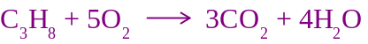

  - Explain which element(s) have been reduced: [2]

The oxidation number of oxygen went from 0 → -2, therefore reduced.
  - Explain which element(s) have been oxidised: [2].
The oxidation number of carbon went from 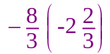 to +4, therefore oxidised.
- Name the following hydrocarbons: [3]
  - 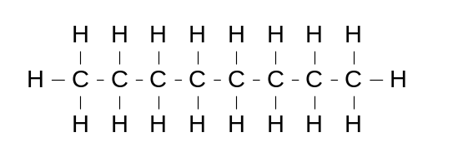 Octane

  - 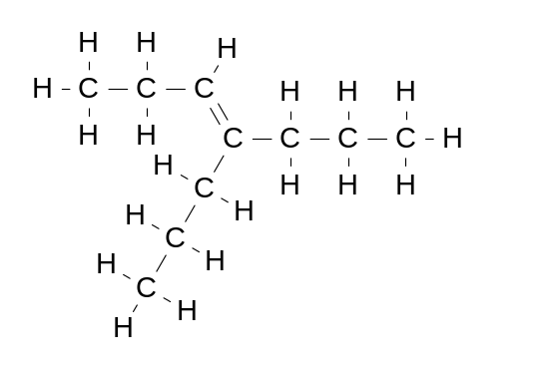 4-propylhept-3-ene

  - 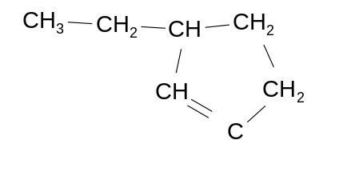 3ethylcyclopentene
- Draw the full structural formula for the following: [2]

- Methylpropane | - Cis 2,3-dichloropent-2-ene
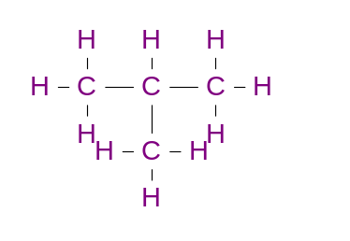 | 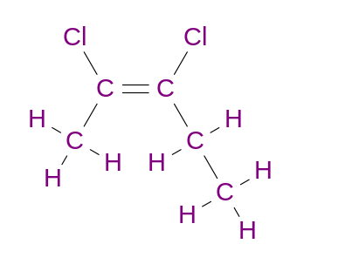

- But-1-ene has the formula C₄H₈.Draw and name three isomers of but-1-ene. [6]

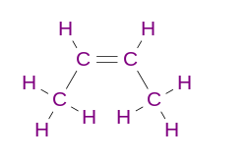 | 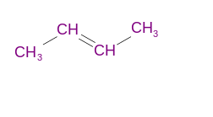 | 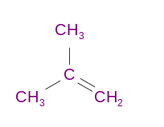 | 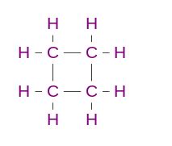 | 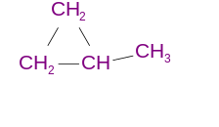
cis-but-2-ene | trans-bute-2-ene | methylpropene | cyclobutane | methylcyclopropane

END OF TEST
Now for the exam!

